## Discrete Mathematics

Background

This topic deals with fundamentals of discrete mathematics (counting, relations, functions and partially ordered sets).

* **Mathematical Logic**

Prove identities/equalities/inequalities by induction

* **Counting**

multiplication principle, sumrule and the five basic formulas

pigeonhole principle

* **Relations and Digraphs**

Directed graphs, matrix of finite relation

Properties of relations on a set of pairs (reflexivity, irreflexivity,

symmetry, asymmetry, antisymmentry, transitivity)

transitive closure of a relation.

* **Functions**

one-to-one, onto, bijective, invertible and inverses

* **Order Relations and Structures**

Partial order (set + relation)

Isomorphic (two partial orders)

**Lesson 0**

Mathematical Induction

(From COS2601)

This essentially is the same as using a recursive definition to define a language. It uses a trick which allows you to prove a statement about an arbitrary number n by first proving it is true when n is 1 and then assuming it is true for n=k and showing it is true for n=k+1.

**Proof by induction:**

|  |  |
| --- | --- |
| Recursive Definition | Clause |
| Show n=1 is true (LHS = RHS) | Basis Clause |
| substitute k into formula (LHS) | Inductive Clause |
| Substitute k+1 into formula (RHS) | Extremal clause |

Example ASS 01 Q1a

Let $P(n)$ be the statement

$1 + 3 +… + (2n + 1) = {\left(n + 1\right)}^{2}$

**Basis Clause**

Show that $n=1$

$$LHS = 1 + 3 +… + \left(2n + 1\right)$$

$= \left(2n + 1\right)$

$= \left(2(1) + 1\right)$

$= 3$

$RHS = {\left(n + 1\right)}^{2}$

$= n^{2}+2n+1$

$= {(1)}^{2}+2(1)+1$

$= 3$

$=4$

$P(n)$ is where $n=1$

$LHS =RHS=3$.

Therefore, $P(n)$ is true

**Inductive Hypothesis**

Show that $n=k$.

$P(k)$ is where $n=k$

Assume $k$

$1 + 3 +… + (2k + 1) = {\left(k + 1\right)}^{2}$

**Extremal Clause**

If $P(k)$ is true, then $P(k+1)$ must also be true

Assume $k+1$

$1 + 3 +… + \left(2k+3\right) = {\left(k + 2\right)}^{2}$

$$LHS = 1 + 3 +… + \left(2(k+1) + 1\right)$$

$$= 1 + 3 +… + \left(2k+2 + 1\right)$$

$$= 1 + 3 +… + \left(2k+3\right)$$

$RHS = {\left((k+1)+ 1\right)}^{2}$

$={\left(k+2\right)}^{2}$

$LHS = 1 + 3 +…+\left(2k + 1\right)+ \left(2k + 3\right)$

But, $1 + 3 +…+\left(2k + 1\right) {=\left(k + 1\right)}^{2}$

Therefore, by the induction hypothesis:

$= {\left(k + 1\right)}^{2}+\left(2k + 3\right)$

$= k^{2}+2k+1+2k+3$

$= k^{2}+4k+4$

$={\left(k+2\right)}^{2}$

$RHS ={\left(k+2\right)}^{2}$

$LHS =RHS$

Thus, $P(k+1)$ is true

Hence, $P(k)$ is true

It then follows by mathematical induction that $P(n)$ is true.

Example ASS 01 Q1a

Let $P(n)$ be the statement

$1+3^{n}< 4^{n}$

**Basis Clause**

Show that $n=2$

$LHS = 1+3^{n}$

$= 1+3^{2}$

$= 10$

$RHS = 4^{n}$

$= 4^{2}$

$= 16$

$=4$

$P(n)$ is where $n=2$

$10<16$ and $LHS<RHS$

Therefore, $P(n)$ is true

**Inductive Hypothesis**

Show that $n=k$

$P(k)$ is where $n=k$

Assume $k$

$1+3^{k}< 4^{k}$

**Inductive Step**

If $P(k)$ is true, then $P(k+1)$ must also be true

Assume $k+1$

$1+3^{(k+1)}< 4^{(k+1)}$

$LHS = 1+3^{(k+1)}$

$= 1+{3.3}^{k}$

$RHS =4^{(k+1)}$

$={4.4}^{k}$

But, $1+{3.3}^{k}$ $<$ ${4.4}^{k}$

Therefore, by the induction hypothesis:

$1+{3.3}^{k}<4(1+3^{k})$

$1+{3.3}^{k}<\left(3+1\right)\left(1+3^{k}\right)$ Re-write 4 as 3+1

$1+{3.3}^{k}<3+{3.3}^{k}+1+3^{k}$ Multiplying out

$1+{3.3}^{k}<\left({1+3.3}^{k}\right)+\left(3+3^{k}\right)$ By regrouping

$0<3+3^{k}$ Remove $\left({1+3.3}^{k}\right)$ from both sides

$0<3+3^{k}$ is true for all $k≥2$

$LHS<RHS$

Thus, $P(k+1)$ is true

Hence, $P(k)$ is true

It then follows by mathematical induction that $P(n)$ is true for $n≥2$

Example

TODO: example with induction to prove divisibility

**Lesson 1**

Counting

Being able to count the number of ways something can happen.

**Product Rule (AND)**

* Procedure can be broken down into a sequence of tasks
* Number of outcomes of each task is $n_{1}$
* $n_{1}.n_{2}.n_{3}…n_{k}$ different ways to perform a procedure

Example: If I have 4 different t-shirts and 3 different pairs of shorts, how many outfits do I have?

$n_{1}.n_{2}$

$4.3=12$

**Tree diagram**

* A visual strategy we can use to represent counting problems
* This is good if you are focused on a particular outcome

Example: If I have 4 different t-shirts and 3 different pairs of shorts, how many outfits do I have?

s1 t1s1

t1 s2 t1s2

s3 t1s3

s1

t1 s2

s3

s1

t1 s2

s3

s1

t1 s2

s3

**Sum Rule (OR)**

* If a task can be performed in one of $n_{1}$ or $n_{2}$ ways, then there are $n_{1}+n_{2}$ ways to perform the task.

Example: I want to take a trip to the beach. I can travel to one of 37 international beaches of one of 14 domestic beaches. How many beach destination choices do I have?

**Subtraction Rule (Inclusion exclusion)**

* If a task can be done in either one of $n_{1}$ or $n_{2}$ ways, then the total number of ways to do the task is $n_{1}+n_{2}$ minus the number of ways that are common

Example: how many bitstrings of length 7 either start with 1 bit of end with 3 bits 000?

Number that start [1][ ][ ][ ][ ][ ][ ] $2^{6}$ $|A|$

with 1

Number that end [ ][ ][ ][ ][0][0][0] $2^{4}$ $|B|$

with 000

Number that start with 1 [1][ ][ ][ ][0][0][0] $2^{3}$ $|A∩B|$

and end in 000

$\left|A∪B \right|=\left|A\right|+\left|B\right|-|A∩B|$

$=2^{6}+2^{4}-2^{3}$

$=64+16-8$

$=72$

**Division Rule**

* There are is $\frac{n}{d}$ ways to do a task if it can be done using a procedure that can be carried out in $n$ ways, where the corresponding outcomes per group.

Example: how many ways can I sit 6 people around a circular table where two seats are considered the same when each person has the same left and right neighbour?

***Set one person and then the rest***

**Lesson 2**

Permutations and Combinations

**Permutation**:

number of elements in the set

number of elements chosen

* An ordered arrangement of unlike objects.
* An r-permutation is the arrangement of r-elements of a set

Example: Let . Find all 2-permutations

Example: How many ways can 100 marathon runners place 1st, 2nd, and 3rd?

number of elements in the set

number of elements chosen

**Combination**:

* An unordered arrangement of unlike objects.
* An r-combination is a subset of the set with r-elements

Example: Let . Find all 2-combinations. Relate this to the number of 2-permutations

Example: how many poker hands of 5 cards can be dealt from a standard of 52 cards

Example: how many diagonals does a convex polygon with n sides have?

**Lesson 3**

Counting Continued

<https://app.creately.com/> - Venn Diagrams

Formulas can be applied to these five basic types:

Arrangements

* No repetition (n!)
* Fixed repetition (Apply Division Rule)
* Unlimited repetition

Combinations

* No repetition (Apply product Rule)
* Unlimited

Example: Consider numbers (strings) of length 5 over the ten digits 0,1,2,3…8,9. Suppose repetition of digits allowed.

The numbers may begin with 0

.

How many different numbers are there?

[10][10][10][10][10] *each position has 10 options (incl 0)*

1. How many of these numbers have no 0?

[9][9][9][9][9] *each position has 9 options (excl 0)*

1. A picture containing table, clock

   Description automatically generatedHow many of these numbers have at least one 0?

*compliment of*

1. How many of these numbers have exactly three 0’s

[0][0][0][9][9] *each position has 9 options (excl 0)*

Example: Arrangement, no repetition

How many ways can you arrange the letters in the word TALES?

Example: Arrangement, repetition

How many ways can you arrange the letters in the word BARBARIC?

*repetition*

*A or B*

*8 elements, Bx2, Ax2, Rx2, Ix1, Cx1*

Question 2: A group of 40 people consists of 20 women and 20 men.

How many ways are there to

(a) arrange the entire group in a row?

(b) form a row of 6 people from the men?

(c) form the group into a row with all the women in front of all the men?

(d) choose a man and a woman from the group?

(e) choose 6 women and 10 men from the group?

(f) choose 15 people from the group?

(g) pair the women and men off?

(h) form 12 pairs from the group?

(i) divide the group into 3 groups (groups 1, 2, 3) of equal size?

(j) divide the group into 3 equal groups, where each group in its own has as many men as women in it?

(k) divide the groups into two groups of equal size such that group 1 contains at least 2 men?

**Lesson 4**

Pigeonhole principle

Given items and containers, if , there is at least one container with items.

Example: Twenty cards numbered 1 to 20 are placed face down on a table. Cards are selected one at a time and turned over. If two of the cards add up to 21, the player loses. Use the pigeonhole principle to show that if 11 cards are chosen then the player can never win the game. State clearly what the pigeons and the pigeonholes are.

Pair the cards according to their numbers as follows:

(1; 20) ; (2; 19) ; (3; 18) ; (4; 17) ; (5; 16) ; (6; 15) ; (7; 14) ; (8; 13) ; (9; 12) ; (10; 11) :

We note that the numbers on each pair of cards add up to 21.

Consider the pairs of cards, adding up to 21, as the pigeonholes. There are 10 pairs. Consider the 11 cards that are chosen as the pigeons. Assign each of these cards according to its number to the pair in which the number occurs. Since there are more pigeons (11) than pigeonholes (10), then at least one of the pigeonholes will have 2 pigeons, i.e. two of the chosen cards will add to 21, and the player loses the game.

**Lesson 5**

Functions

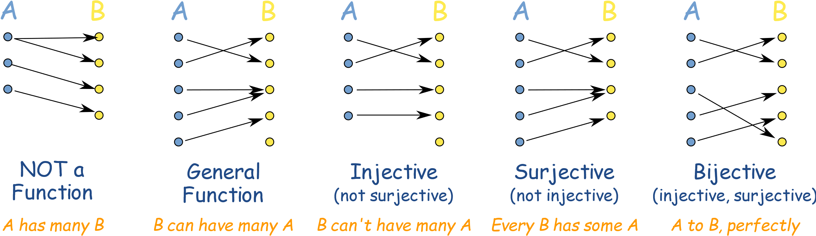

*many-to-one one-to-one one-to-one*

*correspondence*

**Lesson 6**

Relations

Relations can be represented using matrices or diagraphs

Example: Let A be the set {1, 2, 3, 4}. Which ordered pairs are

in the relation R = {(a, b) | a divides b}?

1 divides everything (1,1), (1,2), (1,3), (1,4)

2 divides itself and 4 (2,2), (2,4)

3 divides itself (3,3)

4 divides itself (4,4)

So, R = {(1,1), (1,2), (1,3), (1,4), (2,2), (2,4), (3,3), (4,4)}

**Diagraphs**

1 1

2 2

3 3

4 4

**Matrices**

|  |  |  |  |  |
| --- | --- | --- | --- | --- |
|  | **1** | **2** | **3** | **4** |
| **1** | **x** | **x** | **x** | **X** |
| **2** |  | **x** |  | **x** |
| **3** |  |  | **X** |  |
| **4** |  |  |  | **x** |

Binary relation

* or is a subset of the Cartesian product

*“x is related to y”*

* The binary relation is a set of ordered pairs where and
* if

There are different ways to define binary relations.

Representing relations

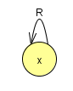

**reflexive**

if for all

*For all x,* *x is related to x (x is related to itself)*

A relation cannot be both reflexive and irreflexive

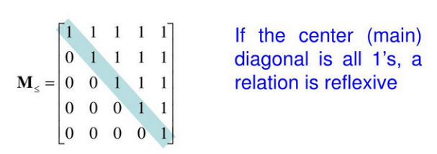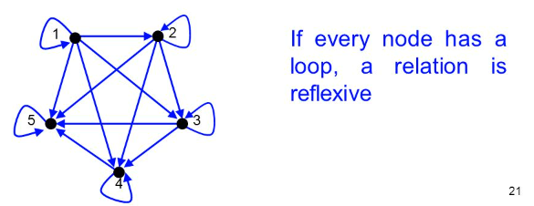

**irreflexive** if for all

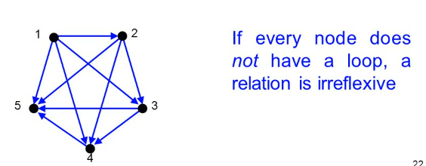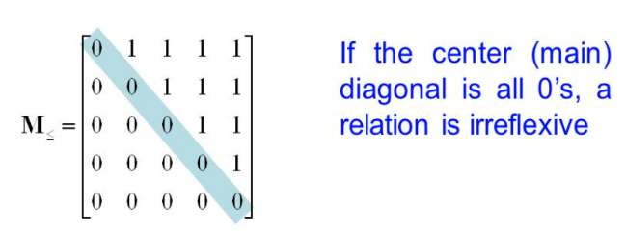

**symmetric**

if for all

*For all x and y, if x is related to y, y is related to x*

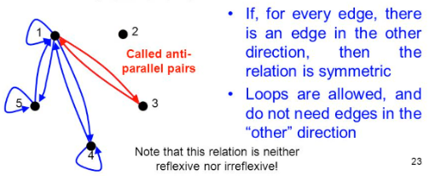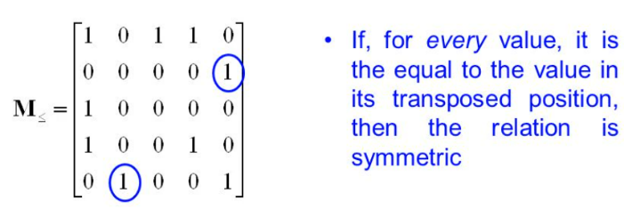

**asymmetric**

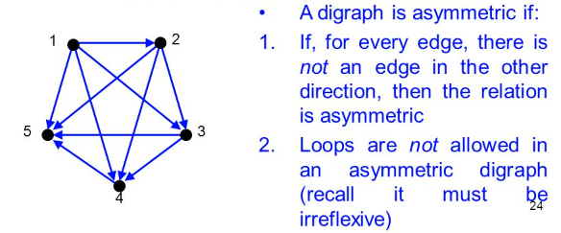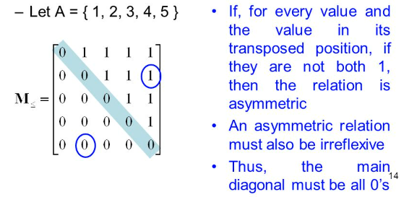

****transitive** if

for all

*For all x, y and z, if x is related to y and y is related to z, then x is related to z*

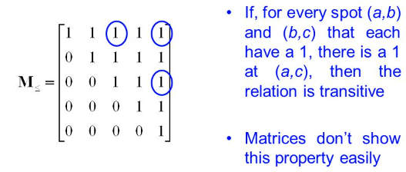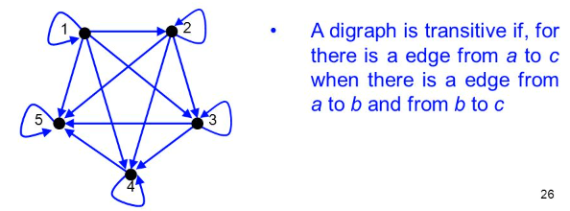

**antisymmetric** if for all

antisymmetry is not the opposite of symmetry

*repetition*

Example

The empty relation is the subset

It is clearly irreflexive, hence not reflexive

From COS2601

What is the difference between Λ and ?

Λ - **ϵ is a word**. represents the set that contains only the empty string {ε}

|{ϵ}|=1 *size of is one element*

– **is a language.** represents the empty set of strings ∅={}.

S = {} =

|∅|=0 *size of is zero elements*

Example: Which of the following relations are reflexive, symmetric,

antisymmetric, and/or transitive?

|  |  |  |  |  |
| --- | --- | --- | --- | --- |
|  | Reflexive | Symmetric | Antisymmetric | Transitive |
|  | • |  | • | • |
|  |  |  | • | • |
|  | • | • |  | • |
|  | • | • | • | • |
|  |  |  | • |  |
|  |  | • |  |  |

**Lesson 7**

Equivalence

An equivalence relation on a set , is a relation on which is

reflexive, symmetric and transitive.

An equivalence class is just a grouping of things that are equivalent to . For example, on set , would be a group of things that are equivalent to 1

Example:

Let *(x equivalent to y)* is divisible by 3, for any

Equivalence Class:

*Start with 2*

*2-5 = -3. This is divisible by 3*

*2-8 = -6. This is divisible by 3*

Equivalence Class:

*Start with 1*

*1-4 = -3. This is divisible by 3*

*1-7 = -6. This is divisible by 3*

Equivalence Class:

*Start with 3*

*3-6 = -3. This is divisible by 3*

*3-9 = -6. This is divisible by 3*

*Each pair consists of pairs where x-y is divisible by 3*

If you need to compute from a matrix draw its equivalent diagraph:

